Quiz 2
Name:
Date: 04.03.2025
Question 1
A) Give the expression of the intensity of light after passing through a layer of this material of thickness $z$ as function of the initial intensity $I_{0}$, thickness $z$, and absorption coefficient $α$:
$$I\left(I_{0},z,α\right)= I_{0}e^{-αz}$$
B) What is the dimension of the absorption coefficient $α$ ? [𝛼]=1/m

C) Let’s consider a material that can absorb light. It means that the refractive index consists of real and imaginary parts:
$$\tilde{n}=n+ik$$
Write the relation between the absorption coefficient $α$ and the extinction coefficient k.
$$α=\frac{4πk}{λ}$$

Question 2
Let’s consider an EM wave incident from half space with refractive index $n_{1}$ to half space with refractive index $n_{2}$ (see the picture below).
Which conditions are required in order that total internal reflectance occurs at the interface for sufficiently large $θ_{i}$? Choose the correct answer:
1) $n_{1}<n_{2}$
2) $n_{1}>n_{2}$
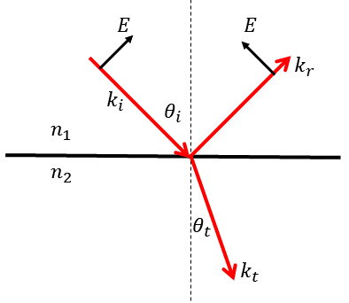
Question 3
Let’s consider a wave incident to the air – diamond interface (see the picture above ↑). Refractive index of air $n_{1}=1$, refractive index of diamond $n_{2}=2.73$.
A) What is the polarization of this wave (from the picture)
1) TE (also called S polarization)
2) TM (also called P polarization)
B) Estimate the value of the reflection coefficient $r$ for incident angle $θ_{I}≪1$. The expressions for reflection coefficient for each polarization are given below.
Hint: Use the formula for the reflectance $R={{(n_{T}-n_{I})}^{2}}/{{(n_{T}+n_{I})}^{2}}$

$$R={{\left(2.73-1\right)}^{2}}/{{\left(2.73+1\right)}^{2}}=\frac{{1.73}^{2}}{{3.73}^{2}}=0.46 \\ For both polarizations$$

